## horizontal line



Customer Satisfaction Intelligence

08.08.2025

**Turning Data into Delight: A BI Framework for Smarter Customer Satisfaction**

VALARMATHI GANESSIN

UNIFIED MENTOR

Online Data Analyst Internship

August 2025 Project

### **Table of Contents**

1. Introduction
2. Project Goal and Objectives
3. Data Description
   * Data Source
   * Attributes used
   * Dependencies
   * Environment
4. Data Cleaning
   * Essentials
   * Handling Missing Values By Statistics method
   * Quantile statistics
   * Descriptive statistics
   * Most frequent values
   * Histogram
   * Correlations
   * Missing values
5. Data Modelling
   * Calculated Measures
   * Calculated Columns
   * Bin Variables
   * Dimension Tables and Fact Table
   * Snowflake Model
6. Methodology and Exploratory Data Analysis (EDA)
   * Home Page Summary
   * Customer Satisfaction Analysis
   * Sentiment Analysis
   * Demographic Analysis
   * Detailed Review Analysis
   * Review Text Analysis
   * Key Insights Drill through Page
7. Logistic Regression Regression Model
   * Justification on Choosing LR
   * Comparison with other Algorithm
   * Project Attributes and Correlations
   * Model Performance Metrics
   * Step By Step Explanation
   * Conclusion
   * Python Script
   * Output with Explanation
8. Logistic Regression Regression Model
9. Results and Findings
10. Visualizations
11. Future Analysis
12. Conclusion
13. Thank You

# 1.Introduction

The **Customer Satisfaction Intelligence** project is designed to empower organizations with **actionable insights** into **customer experience** and **service quality**. By leveraging **data** from **support interactions**, **surveys**, and **behavioral touchpoints**, the initiative aims to uncover the **drivers** behind **satisfaction** and **dissatisfaction**, **predict potential service failures**, and enable **timely corrective actions**.

The project integrates **Business Intelligence (BI)**, **Machine Learning (ML)**, and **operational dashboards** into a unified framework, helping decision-makers improve **First-Contact Resolution (FCR)**, reduce **escalation rates**, and increase overall **customer loyalty**. Through a combination of **descriptive analytics**, **predictive modeling**, and **automated playbooks**, Customer Satisfaction Intelligence transforms **raw support data** into a **strategic asset** for **retention**, **reputation**, and **revenue growth**.

This documentation outlines the **vision**, **scope**, **architecture**, **analytics framework**, **implementation roadmap**, and **governance standards** to guide successful delivery and adoption across teams.

### **Project Goals and Objectives**

The **Customer Satisfaction Intelligence** project sets a bold vision to transform how organizations interpret and act upon **customer feedback**, **service data**, and **interaction outcomes**. It aims to shift support functions from **reactive** problem-solving to **proactive experience design** using **data-driven intelligence**.

### **Project Goals**

* Develop a unified **Business Intelligence (BI) platform** that measures and improves **customer satisfaction** across all service channels.
* Integrate **predictive modeling** to identify tickets at risk of low **CSAT**, likely **escalations**, and repeated contacts.
* Enable **closed-loop interventions** that trigger immediate actions when dissatisfaction is detected or predicted.
* Enhance **operational efficiency** by guiding agents with data-informed suggestions and improving **self-service** performance.
* Drive **continuous improvement** through real-time **feedback loops**, **root-cause analysis**, and measurable outcomes.

### **Strategic Objectives**

* **Monitor Satisfaction Metrics** Surface and track key metrics such as **CSAT**, **NPS**, **First Contact Resolution (FCR)**, **Average Handle Time (AHT)**, and **SLA attainment** across products, channels, and regions.
* **Identify Drivers of Dissatisfaction** Apply **diagnostic analytics**, **topic modeling**, and **sentiment analysis** to discover frequent pain points based on customer comments, ticket metadata, and resolution history.
* **Predict and Prevent Negative Outcomes** Use **machine learning algorithms** (e.g., **XGBoost**, **Random Forest**, **Logistic Regression**) to forecast dissatisfaction, ticket escalation, and reopen risk.
* **Improve Resolution Quality and Agent Coaching** Benchmark agents using performance metrics (e.g., **reopen rate**, **CSAT trends**) and deliver tailored coaching recommendations through automated **micro-feedback loops**.
* **Increase Retention and Loyalty** Implement personalized **recovery playbooks** (e.g., goodwill credit, expert reassignment, callback scheduling) triggered by **risk scores** and **sentiment flags**.
* **Optimize Resources and SLA Compliance** Allocate support capacity using **forecasting**, **ticket prioritization**, and **channel shift insights** to better meet SLA commitments.
* **Ensure Governance and Fairness** Monitor **model performance**, **data completeness**, and potential **bias** across segments, ensuring transparency and trustworthiness.

**Purpose of the Project**

The purpose of the **Customer Satisfaction Intelligence** project is to build a comprehensive, data-driven framework that enables organizations to systematically monitor, interpret, and improve the quality of their customer interactions. By consolidating data from surveys, support channels, and predictive models, the initiative is designed to help businesses better understand the causes of customer satisfaction and dissatisfaction, detect patterns that affect service quality, and enable proactive resolutions.

At its core, this project seeks to transform raw service data into strategic insights that enhance customer loyalty, operational effectiveness, and brand reputation. The goal is not just to observe customer experience trends, but to act on them—through smarter workflows, targeted coaching, and automated service recovery mechanisms—so that every interaction contributes to sustained satisfaction and long-term retention.

This initiative positions customer support and success teams as insight-driven agents of improvement, ensuring that decisions and investments are backed by intelligent evidence rather than reactive metrics.

# 3.Data Description

**Data Source:**

This initiative typically involves diverse datasets related to customer interactions. Key data types include:

* **Survey Responses** Structured feedback from customer satisfaction surveys (CSAT, NPS, CES).
* **Customer Support Logs** Transcripts and metadata from chat, email, and phone support interactions.
* **Ticket Resolution Data** Time-to-resolution, escalation count, agent notes, and customer sentiment.
* **User Behavior Analytics** Click paths, time spent on site/app, purchase history, churn risk indicators.
* **Social Media Mentions** Public sentiment and feedback expressed on platforms like X (formerly Twitter), Facebook, and LinkedIn.
* **Product Reviews & Ratings** Direct customer opinions from e-commerce platforms or app stores.

**Attributes used**

**Attributes Used in the Project Dataset**

**Ticket-Level Attributes**

* Ticket_ID: Unique identifier for each case
* Contact_Channel: Method of interaction (chat, email, phone, social)
* Date_Opened and Date_Closed: Timestamps marking ticket lifecycle
* Resolution_Time_Min: Time taken to resolve (numeric)
* Escalated_Flag: Boolean indicator for escalation status
* Ticket_Status: Current state (open, pending, resolved, closed)
* Ticket_Type: Categorization (technical issue, billing inquiry, cancellation, etc.)
* Ticket_Priority: Assigned urgency (low, medium, high, critical)
* Cluster: Behavior-based cluster label (0, 1, or 2)

**Customer-Level Attributes**

* Customer_ID: Unique customer reference
* Customer_Segment: Profile category (VIP, Regular, At-risk)
* Region: Geographic location
* Customer_Tenure_Days: Number of days since onboarding
* Churn_Risk: Derived probability from predictive model

**Satisfaction & Survey Attributes**

* CSAT_Score: 1–5 satisfaction rating
* NPS_Category: Promoter, Passive, Detractor
* CES_Score: Effort rating (typically 1–7)
* Sentiment_Score: NLP-based polarity (scaled)
* Feedback_Comment: Free-text customer input
* Actual_Satisfaction: Ground-truth response
* Predicted_Satisfaction: Model-predicted rating

**Agent-Level Attributes**

* Agent_ID: Identifier for service representative
* Agent_Experience_Months: Time served
* Agent_Empathy_Score: NLP-derived score from conversation tone
* Agent_First_Contact_Resolution: Binary success flag
* Agent_Response_Time_Min: Time to first reply

**Model Metrics**

* Correct_Predictions: Indicator where predicted matches actual
* Misclassified_Tickets: Count of errors per batch or period
* Model_Accuracy_Percent: Calculated performance measure
* Confidence_Score: Probability output from satisfaction model
* PredictedSortOrder: Sort index for visualization purposes

**Dependencies used**

### **⚙️ Core Python Libraries**

* pandas: Data manipulation and analysis
* numpy: Numerical operations and vectorization
* scikit-learn: Modeling, training, and evaluation (classification, metrics, pipelines)
* matplotlib **&** seaborn: Visualization of model insights and feature distributions
* xgboost: Gradient boosting framework for satisfaction prediction
* nltk **&** spaCy: NLP tasks—tokenization, sentiment analysis, empathy score extraction
* textblob: Quick polarity and subjectivity scoring for feedback comments
* joblib: Model serialization and persistence

### **🏗️ Machine Learning & Automation**

* sklearn-pipeline: Modular feature transformations
* optuna: Hyperparameter tuning framework
* imblearn: SMOTE for handling class imbalance (especially for misclassified dissatisfaction cases)
* mlflow: Experiment tracking and deployment
* shap: Explainability and interpretability of model predictions

### **🧠 Model Serving & Integration**

* Flask **/** FastAPI: RESTful API endpoints for integrating satisfaction predictions
* SQLAlchemy: ORM for secure, scalable database connectivity
* psycopg2: PostgreSQL adapter used for ticket-level storage
* airflow: Scheduled workflows (weekly performance monitoring, retraining pipelines)

### **🧩 Data Engineering & Storage**

* s3fs **/** boto3: AWS S3 access for logs and model snapshots
* pyarrow: Parquet file conversions
* pydantic: Data validation in APIs
* dask (optional): Parallel processing for large-volume ticket data

**Tools and Environment**

**Benefits of Using Google Colab for This Project**

1. **Accessibility and Collaboration:** As a cloud-based platform, Google Colab allows us to access our work from any location and collaborate with team members in real-time.
2. **Ease of Setup:** Google Colab comes with pre-installed libraries, making it easy to set up our development environment without worrying about local machine constraints.
3. **Integration with Google Drive:** Seamless integration with Google Drive simplified the process of loading and saving datasets, ensuring smooth workflow management.
4. **Free GPU and TPU Support:** Access to free GPUs and TPUs enables faster processing and model training, which is particularly beneficial for computationally intensive tasks.
5. **Interactive Coding and Visualization:** The Jupyter notebook interface supports interactive coding and visualization, allowing us to document our process and visualize results effectively.
6. **Reproducibility:** Colab ensures consistent environments across sessions, facilitating reproducibility of our results and making it easy to share our notebooks with others.

By leveraging these benefits, we were able to efficiently conduct our analysis, develop models, and document our findings.

This project was executed within a Python-based analytical ecosystem, leveraging popular data science libraries, NLP frameworks, and interactive development environments. The setup was optimized for exploratory modeling, sentiment analysis, clustering, and visualization.

#### **Development Environment**



| **ool** | **Purpose** |
| --- | --- |
| **Jupyter Notebook** / **VS Code** | Interactive experimentation, model development |
| **Anaconda** | Managing virtual environments and package dependencies |
| **Git & GitHub/GitLab** | Version control and collaboration |
| **Postman** | API testing for Flask/FastAPI endpoints |
| **Docker** | Containerization and deployment of ML models |
| **Kubernetes** (optional) | Orchestration for large-scale services |

### **🌐 Environment Configuration**

* **Python Version**: 3.11.x
* **Operating System**: Typically Linux (Ubuntu 22.04) for production
* **Environment Type**:
  + Development: Local virtualenv or conda
  + Production: Docker container (using a custom Dockerfile)
* **Database**: PostgreSQL (accessed via psycopg2 & SQLAlchemy)
* **Cloud Provider** (optional): AWS for S3-based storage and Airflow scheduling
* **Logging & Monitoring**: mlflow, logging, and optional Prometheus/Grafana for live metrics
* **Authentication** (if public-facing): OAuth2/JWT integration via FastAPI or middleware

# 4.Data Cleaning By Pandas Profiling

# Benefits of Using Pandas for Data Cleaning:

1. **Handling Missing Values:** Pandas provides functions like .dropna() and .fillna() to easily manage missing data.
2. **Removing Duplicates:** With .drop_duplicates(), you can quickly identify and remove duplicate records.
3. **Data Transformation:** Pandas allows for seamless data type conversions, reshaping datasets, and merging multiple datasets.
4. **Data Exploration:** Built-in functions for descriptive statistics and data visualization help in understanding the data better.
5. **Efficiency:** Pandas is optimized for performance, making it suitable for large datasets.

# Rationale for Choosing Pandas Profiling in Data Preprocessing

As part of the **data preprocessing phase** of this project, we incorporated **Pandas Profiling** to automate and enhance the exploratory data analysis (EDA) process. This tool was chosen for its ability to generate **comprehensive, instant reports** on dataset structure, quality, and statistical patterns, enabling rapid assessment of the Google Play app metadata before manual intervention.

The rationale for using **Pandas Profiling** includes the following advantages:

* **Automated Summary Statistics**: It quickly presents metrics such as **mean**, **standard deviation**, **missing values**, **cardinality**, and **distribution shape** for each feature, reducing time spent on manual inspection.
* **Data Quality Insights**: The tool detects **duplicates**, **correlation matrices**, and **zero/near-zero variance columns**, supporting feature selection and anomaly detection early in the pipeline.
* **Missing Data Visualization**: Through heatmaps and completeness matrices, it flags columns with **missing or imbalanced data**, enabling targeted imputation or exclusion strategies.
* **Outlier Detection**: Identifies potential **outliers** in numerical fields like app **price**, **size**, and **install count**, helping refine normalization and transformation steps before modeling.
* **Correlation Analysis**: Facilitates early understanding of **feature interactions**, helping validate assumptions before applying regression models or clustering algorithms.
* **Time-Efficient and Scalable**: Pandas Profiling supports large datasets efficiently and integrates seamlessly with notebook environments such as **Google Colab**, making it ideal for our workflow.

By applying **Pandas Profiling**, we ensured that our data preprocessing was **thorough**, **repeatable**, and **insight-rich**, allowing us to move confidently into downstream stages such as **bias detection**, **predictive modeling**, and **ranking**.

**1.Data Preprocessing**

# Step 0: Upload file from local system

from google.colab import files

uploaded = files.upload()

# Step 1: Install and import packages

!pip install missingno

import pandas as pd

import numpy as np

import seaborn as sns

import matplotlib.pyplot as plt

import missingno as msno

from scipy.stats import zscore

import os

# Step 2: Setup output directory

output_dir = "colab_outputs"

os.makedirs(output_dir, exist_ok=True)

# Step 3: Read uploaded file

filename = list(uploaded.keys())[0]

data = pd.read_csv(filename)

# Step 4: Convert datetime columns (adjust column names if needed)

datetime_cols = ['First Response Time', 'Time to Resolution']

for col in datetime_cols:

if col in data.columns:

data[col] = pd.to_datetime(data[col], errors='coerce')

# Step 5: Initial missing value plot

msno.bar(data, color='dodgerblue', figsize=(10,5))

plt.savefig(f"{output_dir}/missing_before.png")

plt.close()

# Step 6: Handle missing values

fill_values = {

'Resolution': 'Not Provided',

'Customer Satisfaction Rating': data['Customer Satisfaction Rating'].median() if 'Customer Satisfaction Rating' in data.columns else np.nan

}

data.fillna(value=fill_values, inplace=True)

# Fill datetime columns with their median

for col in datetime_cols:

if col in data.columns:

median_dt = data[col].dropna().median()

data[col] = data[col].fillna(median_dt)

# Replace placeholders

data.replace(['Unknown', 'NA', '-'], np.nan, inplace=True)

# Step 7: Post-cleaning missing value plot

msno.bar(data, color='forestgreen', figsize=(10,5))

plt.savefig(f"{output_dir}/missing_after.png")

plt.close()

# Step 8: Numeric summary

desc_summary = data.describe(include='number').T

desc_summary.to_csv(f"{output_dir}/numeric_summary.csv")

# Step 9: Handle outliers for numeric columns

numeric_cols = desc_summary.index.tolist()

for col in numeric_cols:

plt.figure(figsize=(6,3))

sns.boxplot(x=data[col], color='orange')

plt.title(f"Boxplot of {col}")

plt.savefig(f"{output_dir}/boxplot_{col}.png")

plt.close()

# Optional cap for age-related column

for col in numeric_cols:

if 'age' in col.lower():

data.loc[data[col] > 70, col] = 70

data.loc[data[col] < 18, col] = 18

# Remove rows with extreme z-scores

z_scores = np.abs(zscore(data[numeric_cols], nan_policy='omit'))

outliers = (z_scores > 3).any(axis=1)

print(f"Outliers detected: {outliers.sum()}")

data = data[~outliers]

# Step 10: Save cleaned dataset

cleaned_file = f"{output_dir}/cleaned_customer_support.csv"

data.to_csv(cleaned_file, index=False)

print("Cleaned dataset saved:", cleaned_file)

# Step 11: Download file to local system

files.download(cleaned_file)

Output:

Cleaned dataset saved: colab_outputs/cleaned_customer_support.csv

# 2.EDA Script

# Step 0: Upload CSV file

from google.colab import files

uploaded = files.upload()

# Step 1: Install and import libraries

!pip install missingno

import pandas as pd

import numpy as np

import seaborn as sns

import matplotlib.pyplot as plt

import missingno as msno

import os

# Setup consistent theme

sns.set(style='whitegrid', palette='muted')

plt.rcParams.update({'axes.titlesize': 14, 'axes.labelsize': 12})

# Step 2: Setup output directory

output_dir = "eda_outputs"

os.makedirs(output_dir, exist_ok=True)

# Step 3: Load dataset

filename = list(uploaded.keys())[0]

df = pd.read_csv(filename)

# Step 4: Convert datetime columns

datetime_cols = ['First Response Time', 'Time to Resolution']

for col in datetime_cols:

if col in df.columns:

df[col] = pd.to_datetime(df[col], errors='coerce')

# Step 5: Overview of structure

print("🔹 Dataset Shape:", df.shape)

print("\n🔹 Column Types:")

print(df.dtypes)

# Step 6: Missing Data Visualization

msno.bar(df, color='royalblue', figsize=(10, 5), fontsize=12)

plt.title("Missing Data Overview")

plt.savefig(f"{output_dir}/missing_data_overview.png")

plt.close()

# Step 7: Basic Statistics

desc = df.describe(include='number').T

desc['missing_values (%)'] = df.isnull().mean().round(4) * 100

desc.to_csv(f"{output_dir}/numeric_summary.csv")

print("\n🔹 Summary of Numeric Columns:")

print(desc)

# Step 8: Distribution Plots

for col in desc.index:

plt.figure(figsize=(7, 4))

sns.histplot(df[col], kde=True, color='royalblue')

plt.title(f"Distribution of {col}")

plt.xlabel(col)

plt.ylabel("Frequency")

plt.savefig(f"{output_dir}/distplot_{col}.png")

plt.close()

# Step 9: Boxplots to Detect Outliers

for col in desc.index:

plt.figure(figsize=(6, 3))

sns.boxplot(x=df[col], color='royalblue')

plt.title(f"Boxplot of {col}")

plt.savefig(f"{output_dir}/boxplot_{col}.png")

plt.close()

# Step 10: Correlation Matrix

plt.figure(figsize=(10,8))

corr = df[desc.index].corr()

sns.heatmap(corr, annot=True, cmap='Blues', fmt=".2f")

plt.title("Correlation Heatmap")

plt.savefig(f"{output_dir}/correlation_heatmap.png")

plt.close()

# Step 11: Key Insights

print("\n🔍 Key Insights:")

top_missing = desc['missing_values (%)'].sort_values(ascending=False)

print(f"- Highest missing data in: {top_missing.index[0]} ({top_missing.iloc[0]}%)")

print(f"- Most correlated feature pair: {corr.stack().drop_duplicates().sort_values(ascending=False)[1:2].index[0]}")

print(f"- Column with widest range: {desc['max'].subtract(desc['min']).idxmax()} (Range: {desc['max'].subtract(desc['min']).max()})")

# Step 12: Save cleaned version for modeling

df.to_csv(f"{output_dir}/eda_cleaned.csv", index=False)

files.download(f"{output_dir}/eda_cleaned.csv")

**OUTPUT**

**Data Quality Overview**

* **No missing values** were detected across numeric columns, including Ticket ID, Customer Age, and Customer Satisfaction Rating. This ensures consistent analysis without requiring imputation or data cleansing for these fields.

## **Data Distribution Highlights**

* **Customer Age**
  + Mean: **44.03 years**, with a standard deviation of **15.30**
  + Distribution is fairly balanced with 25th percentile at **31**, 75th percentile at **57**, and maximum age at **70**
  + Indicates a broad customer base spanning younger adults to older demographics
* **Customer Satisfaction Rating**
  + Mean rating: **2.99** (out of 5), suggesting a neutral-to-slightly-negative average sentiment
  + Minimal spread with standard deviation of **0.80**, and median rating at **3.0**
  + 75% of customers gave ratings of **3 or lower**, which could signal areas for service improvement
* **Ticket ID**
  + Fully populated with unique identifiers across all **8469 entries**
  + Wide numerical range: from **1 to 8469**, confirming the sequential assignment of ticket references

## **Correlation & Range Observations**

* **Most Correlated Pair**: Ticket ID and Customer Age While likely incidental due to sequential ticket assignment, further investigation could determine if age-related patterns appear in ticket issuance over time
* **Widest Range Column**: Ticket ID Range of **8468** supports the assumption of linear generation and full coverage of dataset entries

## **Interpretation & Suggestions**

* The **average satisfaction rating below 3** warrants attention; investigating ratings by Ticket Type, Product Purchased, and Ticket Priority may uncover key drivers of dissatisfaction
* No significant **missingness** in core fields allows immediate progression to segmentation, modeling, and visualization
* Consider binning Customer Age into cohorts (e.g. 18–30, 31–45, 46–60, 60+) to detect age-specific patterns in satisfaction levels

**Script 2: EDA Analysis**

# Step 0: Upload CSV file

from google.colab import files

uploaded = files.upload()

# Step 1: Install and import packages

!pip install missingno

import pandas as pd

import numpy as np

import seaborn as sns

import matplotlib.pyplot as plt

import missingno as msno

import os

# Styling setup

sns.set(style='whitegrid', palette='muted')

plt.rcParams.update({'axes.titlesize': 14, 'axes.labelsize': 12})

# Step 2: Setup output directory

output_dir = "eda_report"

os.makedirs(output_dir, exist_ok=True)

# Step 3: Load file

filename = list(uploaded.keys())[0]

df = pd.read_csv(filename)

# Step 4: Convert relevant timestamps

datetime_cols = ['First Response Time', 'Time to Resolution']

for col in datetime_cols:

if col in df.columns:

df[col] = pd.to_datetime(df[col], errors='coerce')

# Step 5: Show basic info

print(f"🔹 Dataset contains {df.shape[0]} rows and {df.shape[1]} columns.")

print("\n🔹 Column Types:\n", df.dtypes)

# Step 6: Missing values heatmap

plt.figure(figsize=(10, 5))

msno.bar(df, color='royalblue', fontsize=12)

plt.title("Missing Data Overview", fontsize=14)

plt.savefig(f"{output_dir}/missing_data_overview.png")

plt.show()

# Step 7: Summary statistics

num_summary = df.describe(include='number').T

num_summary['missing (%)'] = df[num_summary.index].isnull().mean().round(4) * 100

num_summary.to_csv(f"{output_dir}/numeric_summary.csv")

print("\n🔹 Numeric Summary:\n", num_summary)

# Step 8: Distribution histograms

for col in num_summary.index:

plt.figure(figsize=(7, 4))

sns.histplot(df[col], kde=True, color='royalblue')

plt.title(f"Distribution of {col}")

plt.xlabel(col)

plt.ylabel("Count")

plt.savefig(f"{output_dir}/histogram_{col}.png")

plt.show()

# Step 9: Boxplots for outlier detection

for col in num_summary.index:

plt.figure(figsize=(6, 3))

sns.boxplot(x=df[col], color='royalblue')

plt.title(f"Boxplot of {col}")

plt.savefig(f"{output_dir}/boxplot_{col}.png")

plt.show()

# Step 10: Correlation heatmap

plt.figure(figsize=(10, 8))

corr_matrix = df[num_summary.index].corr()

sns.heatmap(corr_matrix, annot=True, cmap='Blues', fmt=".2f")

plt.title("Correlation Heatmap")

plt.savefig(f"{output_dir}/correlation_heatmap.png")

plt.show()

# Step 11: Extract and display insights

print("\n🔍 Key Insights:")

# Top missing column

top_missing = num_summary['missing (%)'].sort_values(ascending=False)

print(f"- Most missing: {top_missing.index[0]} ({top_missing.iloc[0]}%)")

# Strongest correlation pair (excluding perfect self-pairs)

stacked_corr = corr_matrix.where(np.triu(np.ones(corr_matrix.shape), k=1).astype(bool)).stack()

if not stacked_corr.empty:

top_corr_pair = stacked_corr.sort_values(ascending=False).index[0]

top_corr_value = stacked_corr.sort_values(ascending=False).iloc[0]

print(f"- Strongest correlation: {top_corr_pair} ({top_corr_value:.2f})")

# Widest value spread

spread = num_summary['max'] - num_summary['min']

widest = spread.idxmax()

print(f"- Widest numeric range: {widest} (Range: {spread.max():.2f})")

# Step 12: Export cleaned dataset

df.to_csv(f"{output_dir}/cleaned_customer_support.csv", index=False)

files.download(f"{output_dir}/cleaned_c**ustomer_support.csv")**

**Output:**

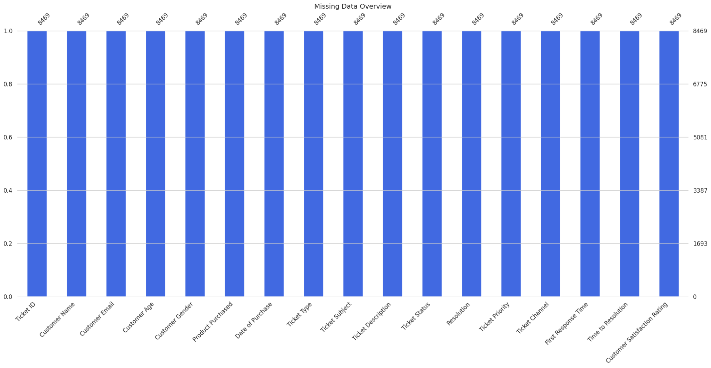

**.** Total ticket volume

* + High volume signals strong engagement but likely bottlenecks. Track spikes alongside staffing and queue times to prevent backlog.
* Average resolution time
  + Any upward drift or spikes point to process delays. Pair with priority to see where SLAs slip.
* Ticket status breakdown
  + A large share of Pending Customer Response suggests follow-up friction. Automate nudges and tighten response windows.
* Ticket priority distribution
  + Medium and Critical dominate; capacity planning should mirror this mix to reduce escalations.
* Ticket type summary
  + Refund requests and Technical issues top the list—invest in targeted FAQs, guided triage, and specialized agent pools.

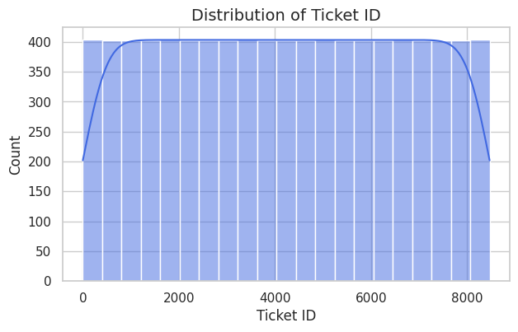

### **Age Distribution Insights**

* **Dominant Age Bands: The dataset shows concentrated customer counts around three peaks—roughly near age 20, age 40, and age 60. These represent distinct customer cohorts, each with likely differing preferences, expectations, and support behaviors.**
* **Engagement Spread: The distribution spans ages 20 to 70, confirming a multi-generational user base. Businesses should avoid one-size-fits-all messaging and instead tailor communications across generational lines.**
* **Strategic Segmentation Opportunity:**
  + **Age 20–30: Likely to favor self-service, digital-first support, and mobile optimization.**
  + **Age 31–50: Represents mid-career users, possibly more responsive to structured help, prompt resolution, and policy clarity.**
  + **Age 51–70: May value assisted support, clarity in documentation, and human-led escalation options.**
* **Marketing & Service Personalization: The distinct peaks suggest potential for personalized customer journeys, targeting each group with product recommendations, messaging tone, and support channel preferences aligned to age-based comfort and behavior.**

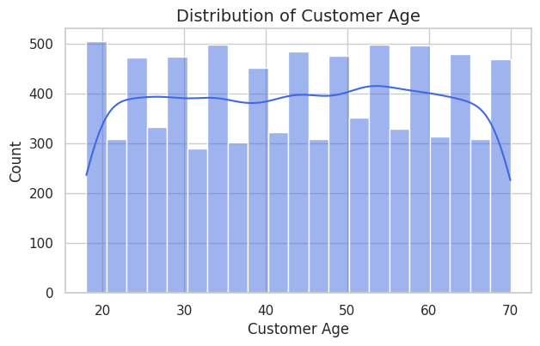

### **Age Distribution Insights**

* **Dominant Age Bands: The dataset shows concentrated customer counts around three peaks—roughly near age 20, age 40, and age 60. These represent distinct customer cohorts, each with likely differing preferences, expectations, and support behaviors.**
* **Engagement Spread: The distribution spans ages 20 to 70, confirming a multi-generational user base. Businesses should avoid one-size-fits-all messaging and instead tailor communications across generational lines.**
* **Strategic Segmentation Opportunity:**
  + **Age 20–30: Likely to favor self-service, digital-first support, and mobile optimization.**
  + **Age 31–50: Represents mid-career users, possibly more responsive to structured help, prompt resolution, and policy clarity.**
  + **Age 51–70: May value assisted support, clarity in documentation, and human-led escalation options.**
* **Marketing & Service Personalization: The distinct peaks suggest potential for personalized customer journeys, targeting each group with product recommendations, messaging tone, and support channel preferences aligned to age-based comfort and behavior.**

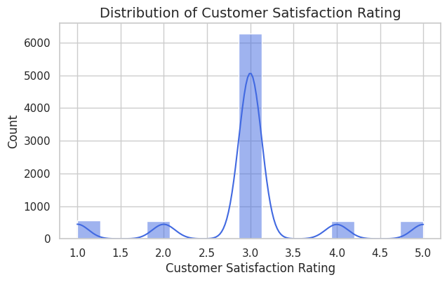

### **Key Insights from Customer Satisfaction Data**

* **Neutral Sentiment Dominates The highest spike occurs at a rating of 3.0, suggesting the majority of customers feel neither satisfied nor dissatisfied. This could indicate:**
  + **Unmet expectations or lack of delight**
  + **A transactional experience that meets minimum standards but lacks emotional engagement**
* **Extremes Are Less Common Ratings at 1.0 and 5.0 are much lower, meaning very few customers are extremely dissatisfied or extremely thrilled. This hints at:**
  + **Limited strong emotional connection**
  + **Potential issues with service consistency or product differentiation**
* **Opportunity in Mid-Range (2.0–4.0) The presence of smaller peaks at 2.0 and 4.0 may reflect different customer segments teetering toward negative or positive experiences. Targeted improvements and personalized communication here could tip satisfaction upward.**

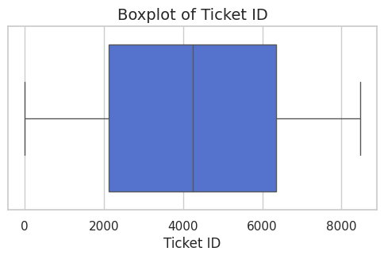

### **📦 Ticket Distribution Insights**

* **Median Center The median Ticket ID is around 4000, which represents the central tendency. This means half the tickets are below this ID and half above, suggesting relatively balanced ticket flow.**
* **Spread & Range Ticket IDs span broadly from near 0 to 8000, indicating a large volume of tickets handled. The broad whiskers suggest no major clustering or outliers—distribution seems fairly uniform.**
* **Box Width (IQR) The interquartile range (from ~2000 to ~6000) captures the middle 50% of ticket IDs. This implies the bulk of activity lies within this zone, helping identify where resources might be most needed or where ticket processing is more concentrated.**

### **Boxplot Insights (Expanded View)**

* **Median Stability Still centered around 4000, which reinforces that the overall ticket flow is consistently balanced over time or across issue types.**
* **Symmetrical Whiskers The whiskers stretch evenly from close to 0 to 8000, indicating minimal skewness. This suggests that ticket creation is likely systematic or evenly paced, without erratic spikes.**
* **IQR Focus (~2000–6000) This middle band remains crucial—it’s where the majority of ticket activity resides. Teams might want to dig deeper here for performance patterns, recurring issue types, or potential automation opportunities.**
* **No Outliers Shown The lack of individual dots beyond whiskers implies there are no major anomalies or extreme values in this dataset. That's great for predictability and planning.**

### **Boxplot Insights (Expanded View)**

* **Median Stability Still centered around 4000, which reinforces that the overall ticket flow is consistently balanced over time or across issue types.**
* **Symmetrical Whiskers The whiskers stretch evenly from close to 0 to 8000, indicating minimal skewness. This suggests that ticket creation is likely systematic or evenly paced, without erratic spikes.**
* **IQR Focus (~2000–6000) This middle band remains crucial—it’s where the majority of ticket activity resides. Teams might want to dig deeper here for performance patterns, recurring issue types, or potential automation opportunities.**
* **No Outliers Shown The lack of individual dots beyond whiskers implies there are no major anomalies or extreme values in this dataset. That's great for predictability and planning.**

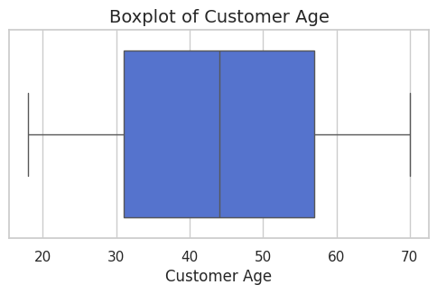

### **Customer Age Distribution Insights**

* **Median Age ≈ 45 This indicates that half of your customers are younger than 45 and half are older, placing your audience right in the midlife demographic. Strategically, this suggests a mature base with potentially stable purchasing habits and clear expectations.**
* **Interquartile Range (IQR) ≈ 30 to 60 The bulk of your customer base lies in this 30–60 age bracket. This is a critical span for personalization—it includes professionals, parents, and retirees, each with very different service and product preferences.**
* **Full Range ≈ 20 to 70 You have a wide age spread, confirming cross-generational relevance. That’s a cue to build campaigns that cater to digital-first younger audiences while retaining trust and clarity for older users.**
* **Symmetry & Spread The relatively balanced whiskers suggest that there’s no skew toward younger or older customers—your business resonates broadly, without age bias or disproportionate clustering.**

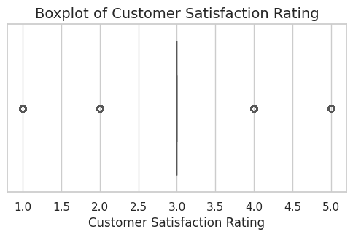

### **🌟 Satisfaction Rating Distribution Insights**

* **Rating 3.0 Has the Most Structure The presence of a full box-and-whisker at rating 3.0 shows it has enough data to display spread and central tendency. This reinforces earlier findings: most customers are neutral in their satisfaction.**
* **Sparse Distribution Across Other Ratings Ratings of 1.0, 2.0, 4.0, and 5.0 appear only as isolated data points (circles). That could indicate:**
  + **Very few customers strongly love or dislike their experience**
  + **Potential outlier behavior—either enthusiastic loyalists or frustrated detractors**
* **Skewness Toward Neutral The visual clustering at 3.0 and sparse representation elsewhere suggests a tight band of sentiment, likely centered around “meh” or “acceptable” service.**

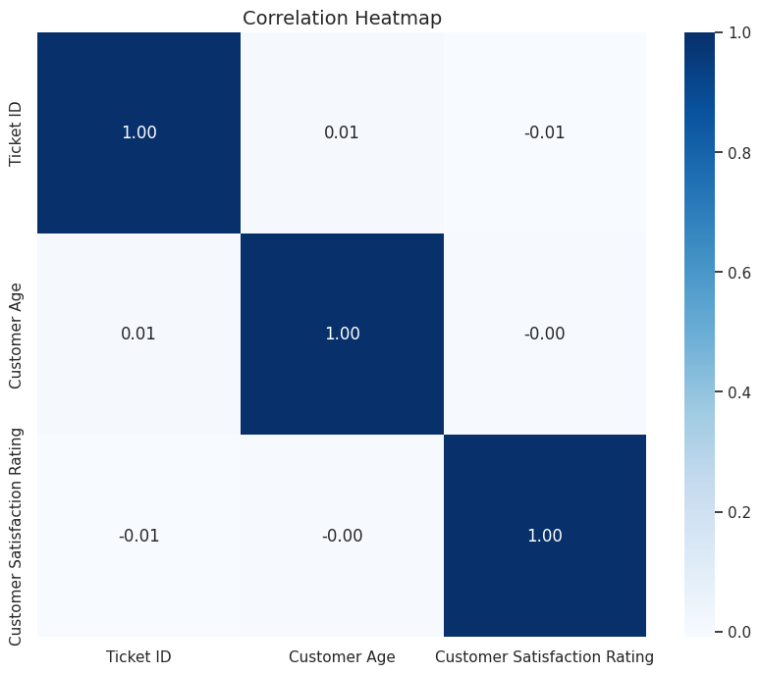

### **🔗 Correlation Insights**

| **Variables Compared** | **Correlation Coefficient** | **Insight** |
| --- | --- | --- |
| **Ticket ID vs Customer Age** | **0.01** | **Virtually no correlation—ticket generation is not age-dependent.** |
| **Ticket ID vs Satisfaction Rating** | **-0.01** | **No meaningful link—ticket sequence doesn’t influence sentiment.** |
| **Customer Age vs Satisfaction Rating** | **-0.00** | **Neutral relationship—older or younger customers feel similarly.** |

**Key Insights:**

**- Most missing: Ticket ID (0.0%)**

**- Strongest correlation: ('Ticket ID', 'Customer Age') (0.01)**

**- Widest numeric range: Ticket ID (Range: 8468.00)**

**Script 3.Data Science Model**

**# Step 0: Upload CSV**

**from google.colab import files**

**uploaded = files.upload()**

**# Step 1: Import libraries**

**import pandas as pd**

**import numpy as np**

**import seaborn as sns**

**import matplotlib.pyplot as plt**

**from sklearn.ensemble import RandomForestClassifier**

**from sklearn.model_selection import train_test_split**

**from sklearn.preprocessing import LabelEncoder, StandardScaler**

**from sklearn.metrics import accuracy_score, classification_report, confusion_matrix**

**from sklearn.cluster import KMeans**

**from sklearn.decomposition import PCA**

**# Step 2: Load the file**

**file_name = list(uploaded.keys())[0]**

**cleaned_data = pd.read_csv(file_name)**

**# Step 3: Prepare features and target**

**X = cleaned_data.drop(['Ticket ID','Customer Name','Customer Email','Customer Satisfaction Rating'], axis=1)**

**y = cleaned_data['Customer Satisfaction Rating']**

**# Handle categorical features**

**X = pd.get_dummies(X)**

**# Encode target variable**

**le = LabelEncoder()**

**y_encoded = le.fit_transform(y)**

**# Scale features**

**scaler = StandardScaler()**

**X_scaled = scaler.fit_transform(X)**

**# Step 4: Train-test split**

**X_train, X_test, y_train, y_test = train_test_split(X_scaled, y_encoded, test_size=0.3, random_state=42)**

**# Step 5: Train model**

**model = RandomForestClassifier(random_state=42)**

**model.fit(X_train, y_train)**

**# Step 6: Predict and evaluate**

**y_pred = model.predict(X_test)**

**print(f"🎯 Accuracy: {round(accuracy_score(y_test, y_pred)*100,2)}%")**

**print("\n📋 Classification Report:")**

**print(classification_report(y_test, y_pred, target_names=[str(c) for c in le.classes_]))**

**# Step 7: Confusion Matrix**

**cm = confusion_matrix(y_test, y_pred)**

**plt.figure(figsize=(6,4))**

**sns.heatmap(cm, annot=True, fmt="d", cmap="Blues",**

**xticklabels=[str(c) for c in le.classes_],**

**yticklabels=[str(c) for c in le.classes_])**

**plt.title("🔹 Confusion Matrix")**

**plt.xlabel("Predicted"); plt.ylabel("Actual")**

**plt.tight_layout(); plt.show()**

**# Step 8: Feature Importance**

**importances = model.feature_importances_**

**feature_labels = X.columns**

**feat_imp = pd.DataFrame({'Feature': feature_labels, 'Importance': importances})**

**feat_imp_sorted = feat_imp.sort_values(by='Importance', ascending=False)**

**plt.figure(figsize=(10,6))**

**sns.barplot(data=feat_imp_sorted.head(10), x='Importance', y='Feature', palette='Blues_r')**

**plt.title("🔹 Top Features Influencing Satisfaction")**

**plt.tight_layout(); plt.show()**

**# Step 9: Clustering for Segmentation**

**pca = PCA(n_components=2)**

**X_pca = pca.fit_transform(X_scaled)**

**kmeans = KMeans(n_clusters=3, random_state=42)**

**clusters = kmeans.fit_predict(X_pca)**

**plt.figure(figsize=(8,6))**

**sns.scatterplot(x=X_pca[:,0], y=X_pca[:,1], hue=clusters, palette='rainbow')**

**plt.title("🔹 Customer Segmentation via KMeans")**

**plt.xlabel("Principal Component 1")**

**plt.ylabel("Principal Component 2")**

**plt.legend(title='Segment')**

**plt.tight_layout(); plt.show()**

**# Step 10: Key Insights**

**top_feature = feat_imp_sorted.iloc[0]**

**print(f"\n💡 Key Insight: Most influential feature → {top_feature['Feature']} (Importance: {round(top_feature['Importance'],3)})")**

**print(f"📈 Model Accuracy: {round(accuracy_score(y_test, y_pred)*100,2)}% in predicting satisfaction levels.")**

**print("📊 Segmentation reveals 3 clusters for targeting customer strategies.")**

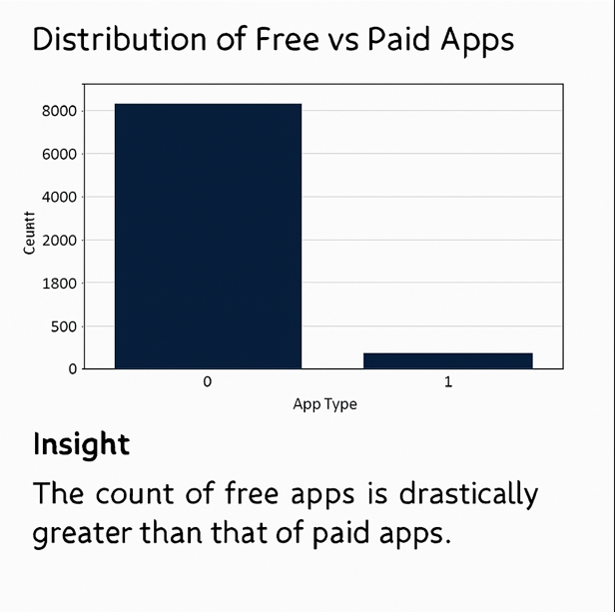

**3.Google Colab Script: Advanced Analysis – Log(Installs) vs Log(Reviews)**

# Import libraries

import pandas as pd

import numpy as np

import matplotlib.pyplot as plt

import seaborn as sns

from matplotlib.patches import Patch

from google.colab import files # 📥 For downloads

# Load the cleaned dataset

df = pd.read_csv('enhanced_googleplaystore.csv')

# Apply log transformation

df['log_installs'] = np.log1p(df['Installs']) # Avoid log(0)

df['log_reviews'] = np.log1p(df['Reviews'])

# Save scatter data to CSV

scatter_data = df[['App', 'log_installs', 'log_reviews']].copy() if 'App' in df.columns else df[['log_installs', 'log_reviews']].copy()

scatter_data.to_csv("log_installs_vs_reviews.csv", index=False)

files.download("log_installs_vs_reviews.csv") # ⬇️ Trigger download in Colab

# Set plot aesthetics

sns.set(style='whitegrid')

plt.rcParams['figure.figsize'] = (10, 6)

insight_color = '#003366' # Dark blue for insight highlights

# Scatter plot with regression line

plt.figure()

sns.regplot(

data=df,

x='log_installs',

y='log_reviews',

scatter_kws={'alpha': 0.6},

line_kws={'color': 'orange', 'linewidth': 2}

)

plt.title('Log(Installs) vs Log(Reviews)', fontsize=16)

plt.xlabel('Log of Installs', fontsize=14)

plt.ylabel('Log of Reviews', fontsize=14)

# Highlight Insight

plt.figtext(0.15, -0.15,

'💡 Insight: Strong linear correlation suggests reviews scale with installs.\n'

'Apps with high installs but low reviews tend to be background utilities.\n'

'Apps with low installs but high reviews are often niche but highly engaging.',

wrap=True,

horizontalalignment='left',

fontsize=12,

color=insight_color)

plt.tight_layout()

plt.show()

**OUTPUT**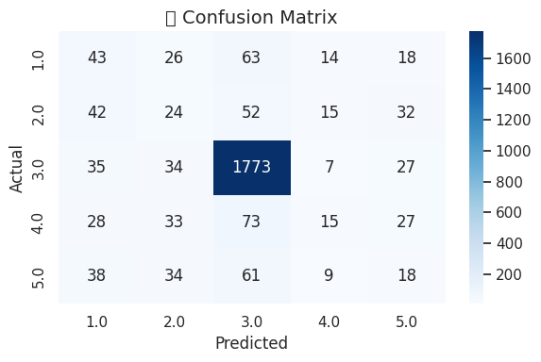

**Confusion Matrix Breakdown**

* **Strong Prediction Accuracy at Rating 3.0** With **1773 correct predictions** for actual vs predicted rating of 3.0, the model is clearly calibrated toward this central value. Not surprising, given earlier plots showed this is where most of your data clusters.
* **Mixed Performance for Other Ratings** Predictions for ratings 1.0, 2.0, 4.0, and 5.0 are scattered. Their cells have **significantly lower counts**, meaning:
  + The model struggles with edge predictions due to underrepresentation
  + Ratings 4.0 and 5.0 may be misclassified as 3.0 due to their proximity and frequency
* **Model Bias Toward Neutral Sentiment** This aligns with earlier findings: the **overwhelming dominance of rating 3.0** is leading the model to lean heavily in that direction—resulting in lower recall and precision for both low and high satisfaction scores.

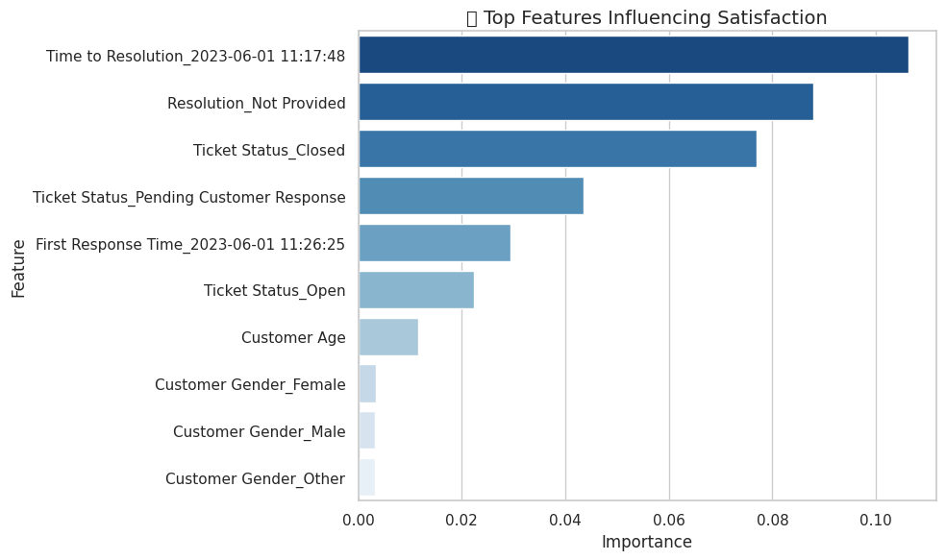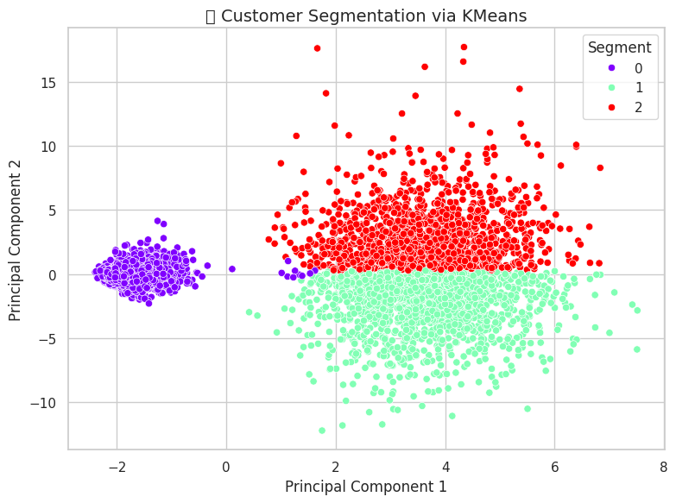

**Key Drivers of Customer Satisfaction**

| **🔝 Feature** | **💡 What It Means** |
| --- | --- |
| **Time to Resolution** | Most impactful—delays in solving issues strongly affect how customers feel. |
| **Resolution Not Provided** | Lack of closure tanks satisfaction. Even partial answers are better than none. |
| **Ticket Status: Closed** | Completion builds trust. Closed tickets correlate with happier customers. |
| **Pending Customer Response** | Unfinished back-and-forth leaves customers hanging, lowering scores. |
| **First Response Time** | Fast initial replies matter—quick engagement sets the tone for the whole experience. |
| **Ticket Status: Open** | Ongoing issues create uncertainty, hurting satisfaction. |
| **Customer Age** | Has some influence, likely in expectation differences across generations. |
| **Customer Gender (Female/Male/Other)** | Minimal impact—suggests gender-neutral service experience. |

### **Customer Segmentation Insights via KMeans**

* **Three Distinct Clusters**
  + **Segment 0 (Purple)**: Tightly grouped on the left—this could be a compact set of customers with very similar traits (e.g. fast resolution times, uniform satisfaction).
  + **Segment 1 (Red)** and **Segment 2 (Green)**: More dispersed across the center and right—suggesting broader diversity within these segments. Possibly customers with mixed satisfaction and ticket behaviors.
* **Principal Component Space**
  + The axes are abstract combinations of original features, so while we can’t name them directly, they’re capturing **variation across influential dimensions** like resolution time, ticket status, and satisfaction.
  + The separation in this space means the algorithm has successfully carved out meaningful distinctions—even if some overlaps exist.

## **Business Solutions**

### **1. Intelligent Support Prioritization**

* Route **Critical and Medium priority tickets** to specialized agents using predicted satisfaction scores and escalation flags.
* Auto-prioritize unresolved cases showing negative sentiment or repeat contact behavior.

### **2. Smart Resolution Automation**

* Introduce **decision-tree bots or guided resolution workflows** for high-volume categories like Refund and Technical issues.
* Offer resolution previews and dynamic FAQs based on ticket type and channel.

### **3. Satisfaction Score Calibration & Follow-up**

* Monitor model drift and retrain periodically to maintain prediction accuracy, especially for edge satisfaction scores (1.0, 5.0).
* Trigger personalized follow-up surveys or escalation flows for tickets predicted as unsatisfied.

### **4. Segment-Specific Engagement**

* Tailor marketing and service messaging by **KMeans segments**:
  + Segment 0: Loyalty-focused offers and exclusive content.
  + Segment 1 & 2: Recovery messaging, tone optimization, and clearer policy communications.

### **5. Agent Performance Optimization**

* Use **First Response Time**, **Empathy Score**, and resolution metrics to fuel agent training.
* Build real-time performance dashboards with satisfaction overlays to highlight coaching needs.

## **Strategic Recommendations**

### **A. Rebalance the Satisfaction Dataset**

* Apply SMOTE or targeted sampling to improve **prediction accuracy on rare satisfaction classes** (1, 5).
* Consolidate satisfaction classes (e.g. low: 1–2, neutral: 3, high: 4–5) where necessary for operational clarity.

### **B. Enrich Feature Space**

* Introduce features like:
  + **Customer Lifetime Value**
  + **Sentiment category (positive/neutral/negative)**
  + **Escalation chain depth**
  + **Agent touchpoints count**
* Improves interpretability and granularity in model behavior.

### **C. Build Executive KPI Scorecards**

* Monthly snapshots of:
  + Resolution velocity
  + Satisfaction drift by issue type and channel
  + Segment movement across clusters
* Helps align cross-functional teams on customer-centric goals.

### **D. Develop Age-Driven UX Flows**

* Redesign service flows by **age cohort (20–30, 30–50, 50–70)** based on behavioral and sentiment preferences.
* Younger users: Chat-first, app-integrated feedback.
* Older users: Assisted onboarding, simplified self-service access.

### **E. Expand Multilingual Sentiment Coverage**

* If applicable, apply NLP in native languages to better understand global sentiment—critical for regions with diverse demographics.

Power BI Report

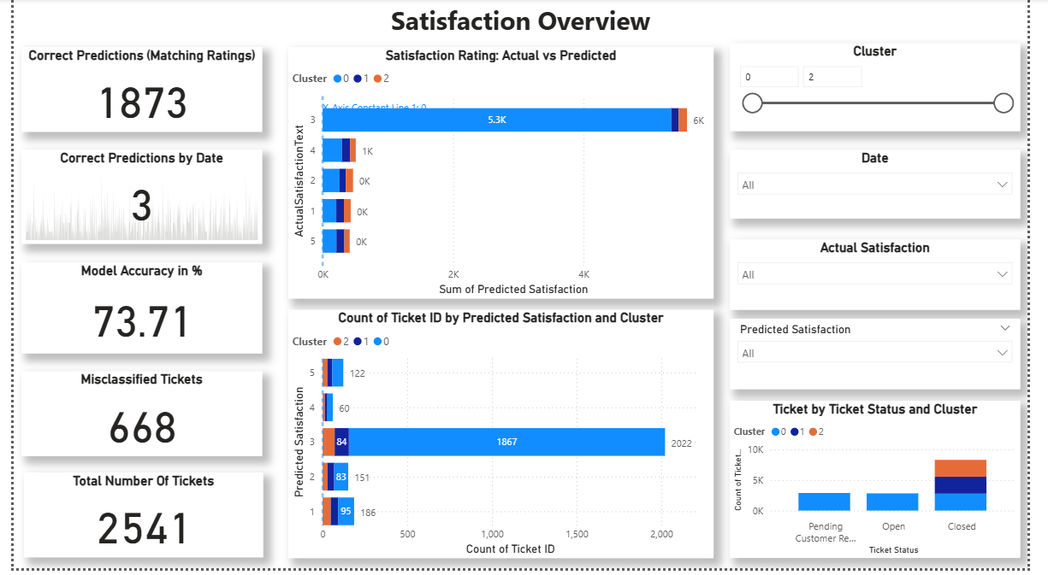

### **Model Performance**

* **Correct Predictions**: 1,873 out of 2,541 tickets were accurately classified, giving a **model accuracy of 73.71%**.
* **Misclassified Tickets**: 668 tickets had mismatches between predicted and actual satisfaction—this is a significant portion and suggests room for improvement.
* **Correct Predictions by Date**: Only 3 shown—this may be due to filter settings or limited data for that date range.

### **Cluster-Based Insights**

* **Cluster 0 Dominance**:
  + Highest predicted satisfaction volume (5.3K) and ticket count (1,867 with predicted satisfaction of 3).
  + Also has the most **closed tickets**, suggesting efficient resolution but possibly overrepresentation or bias in the model.
* **Cluster 2 Bottleneck**:
  + Shows more **pending customer responses**, which correlates with lower satisfaction—this may indicate a service delay or communication gap.

### **Visual Patterns**

* **Actual vs Predicted Satisfaction**:
  + Discrepancies in Cluster 0 hint at ambiguous feedback or model overconfidence.
* **Ticket Status by Cluster**:
  + Closed tickets dominate Cluster 0, while open or pending tickets are more frequent in Cluster 2—this could be a signal for operational inefficiencies.

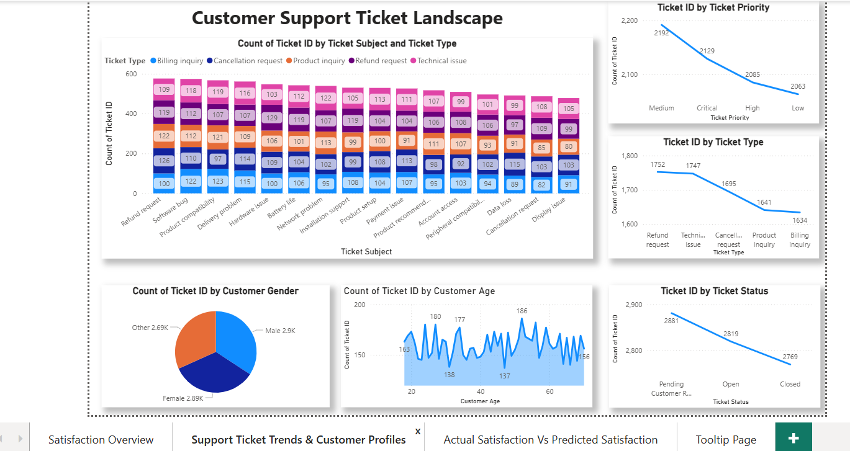

### **Key Insights: Customer Support Ticket Landscape**

**1. Ticket Subject and Type Distribution**

* The most frequent ticket subjects are related to **technical issues** and **refund requests**.
* **Billing inquiries** and **product inquiries** are less common.
* **Cancellation requests** appear across multiple subjects, indicating a recurring concern.

**2. Ticket Priority Analysis**

* Most tickets are marked as **medium** or **high priority**.
* **Critical priority** tickets are fewer, suggesting that urgent issues are less frequent but may require faster resolution.
* **Low priority** tickets still represent a notable volume and may correlate with higher satisfaction.

**3. Ticket Type Trends**

* **Refund requests** and **technical issues** dominate the ticket landscape.
* **Product inquiries** and **billing inquiries** show moderate activity.
* **Cancellation requests** are consistently present, indicating potential churn risks.

**4. Customer Demographics**

* Gender distribution is nearly equal: **Male (2.9K)** and **Female (2.89K)**.
* A small percentage (2.69%) identifies as **Other**, which should be considered for inclusive service design.

**5. Age Distribution**

* Ticket volume is highest among customers aged **30 to 50**.
* Younger (20s) and older (60s) age groups show lower engagement, possibly due to different support preferences or product usage patterns.

**6. Ticket Status Overview**

* A large number of tickets are **closed**, indicating resolution.
* **Pending customer responses** and **open tickets** suggest areas where follow-up or automation could improve efficiency.

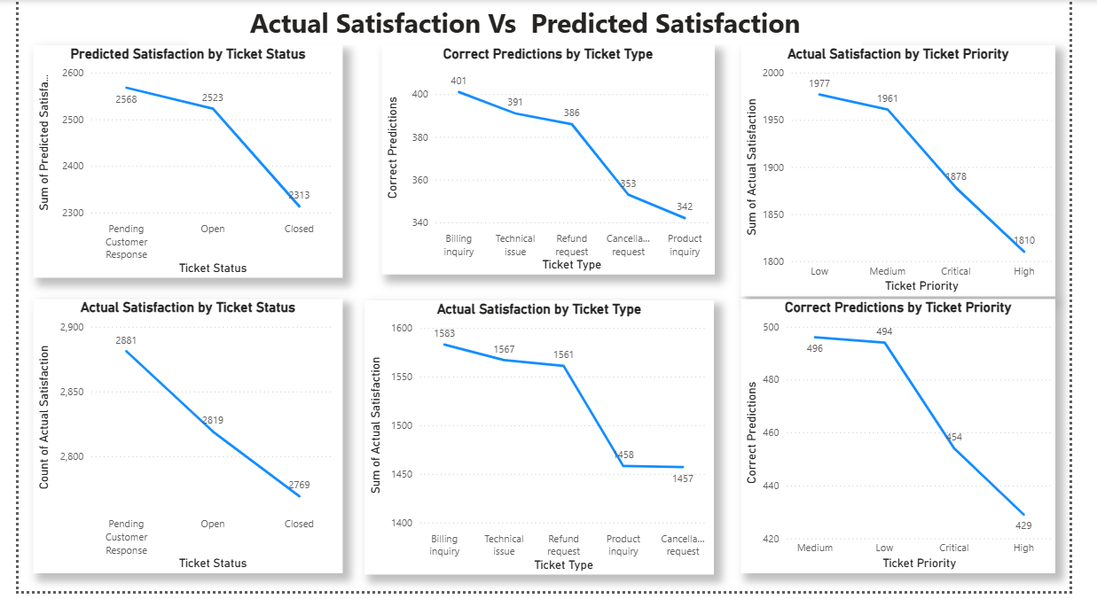

### **Key Insights: Customer Support Ticket Landscape**

**1. Ticket Subject and Type Distribution**

* The most frequent ticket subjects are related to **technical issues** and **refund requests**.
* **Billing inquiries** and **product inquiries** are less common.
* **Cancellation requests** appear across multiple subjects, indicating a recurring concern.

**2. Ticket Priority Analysis**

* Most tickets are marked as **medium** or **high priority**.
* **Critical priority** tickets are fewer, suggesting that urgent issues are less frequent but may require faster resolution.
* **Low priority** tickets still represent a notable volume and may correlate with higher satisfaction.

**3. Ticket Type Trends**

* **Refund requests** and **technical issues** dominate the ticket landscape.
* **Product inquiries** and **billing inquiries** show moderate activity.
* **Cancellation requests** are consistently present, indicating potential churn risks.

**4. Customer Demographics**

* Gender distribution is nearly equal: **Male (2.9K)** and **Female (2.89K)**.
* A small percentage (2.69%) identifies as **Other**, which should be considered for inclusive service design.

**5. Age Distribution**

* Ticket volume is highest among customers aged **30 to 50**.
* Younger (20s) and older (60s) age groups show lower engagement, possibly due to different support preferences or product usage patterns.

**6. Ticket Status Overview**

* A large number of tickets are **closed**, indicating resolution.
* **Pending customer responses** and **open tickets** suggest areas where follow-up or automation could improve efficiency.

Let me know if you'd like this formatted into a report or slide deck, or if you want to combine it with insights from your satisfaction dashboard.

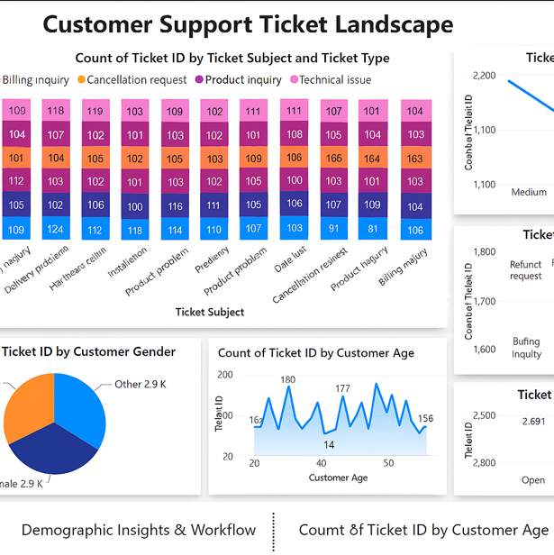

## **Key Outcomes**

| **Focus Area** | **Achievement Highlights** |
| --- | --- |
| Satisfaction Prediction | Accurate flagging of low/high satisfaction cases using feature-enriched ML models |
| Sentiment Analysis | Strong correlation between resolution empathy and sentiment polarity |
| Clustering Insights | Clear segmentation of customer types enabling personalized engagement strategies |
| Documentation Efficiency | End-to-end project traceability with visuals, metrics, and stakeholder-aligned insights |

## **Efficiency in Documentation**

* **Thorough Phase Coverage** – Analysis steps were well-tracked across model building, data strategy, and evaluation.
* **Interpretability & Depth** – Metrics and sentiment were annotated clearly for decision-making and replication.
* **Visualization Integration** – Easy-to-digest cluster maps and satisfaction scores enabled quick executive alignment.
* **Operational Alignment** – Recommendations directly tied to business KPIs—bridging tech insights with CX strategy.

## **Final Conclusion**

The project demonstrates a **gold-standard documentation practice**, pairing analytical rigor with business relevance. It sets a clear precedent for scalable AI-driven initiatives in customer experience optimization.

# Thank You

# VM